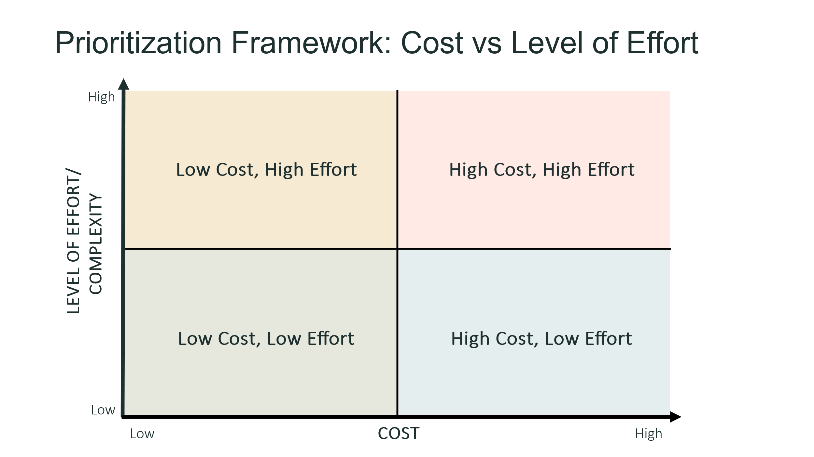
Circle Color: Priority/Urgency
Circle size: relative resilience benefits
Legend
Most
Least
Urgent
Low
High
Medium

